## Contributions of Members

Muhammad Awad Luckhoo

Gathered information, researched about various expert system development tools, compare quality of recommendation of expert system, and compiled report.

Choong Kai Wern

Gathered information, justified expert system design, implemented expert system, implemented uncertainty to expert system, and evaluate the system strengths and weaknesses.

Teh Cuok Syen

Gathered information, researched about various expert system development tools, implemented the expert system, prepared Gantt chart, and compile report.

Ong Li Sheng

Gathered information, justified expert system design, implemented the expert system, implemented uncertainty to expert system, and evaluate the system strengths and weaknesses.

Mu Chun Khang

Gathered information, researched about various expert system development tools, justified expert system design, implemented the expert system, and compiled report.

Mah Qi Hao

Gathered information, justified expert system design, implemented the expert system, implemented uncertainty to expert system and evaluate the system strengths and weaknesses.

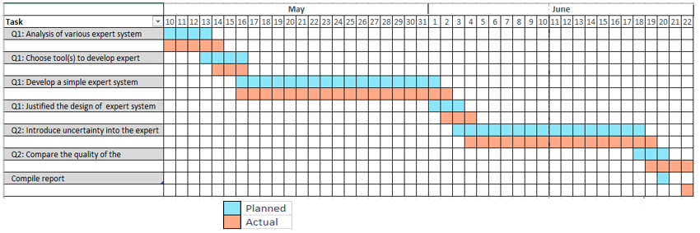

Gantt chart